**Evidence-Based Policy**

**Note on structure/outline**: Evidence-based policy is treated here as a broad umbrella comprising 3 distinct areas. A visual:

|  |  |  |
| --- | --- | --- |
| **Evidence Based Policy** | | |
| Tiered Grantmaking | Learning Agenda | Pay for Success |

*Further note: Content addresses overarching elevator pitch, rationale, and category of uses for evidenced-based policy as a whole, before addressing D1-D9 (see below) for the learning agenda, followed by Pay for Success. Tiered grantmaking content can be found separately.*

|  |
| --- |
| **Content structure outline:**   1. **An “elevator pitch,” which provides highlights of the content, such as why the approach is important, how it works, and examples of where it has worked** 2. **A short, digestible summary of underlying premises and rationales, supported by research (i.e., not a report)** 3. **Profiles of major categories of candidate users, including specific examples of when, and under what circumstances, the approach may be employed, supported by research into the target audience and their needs** 4. **One or more “success stories” or other learning narratives that highlight the impact of and justification for using this approach.** 5. **Documentation of challenges to deployment, and potential limitations of the approach, including barriers or obstacles encountered within agencies employing the approach** 6. **A “How-To” document, detailing key steps for deploying the approach, including promising practices in adaptation and deployment** 7. **An online inventory of resources** 8. **Examples of policy (e.g. legislation, Executive Order, etc.) that have enabled or encouraged the approach** 9. **Future directions (next practices as opposed to best practices)** |

**Pull Quotes:**

“What does it mean […] to create ‘evidence-based initiatives?’ It means that the administration strives to be as certain as possible that Federal dollars are spent on social intervention programs that have been proven by rigorous evidence to work.” [Haskins, R and Margolis, G., *Show Me the Evidence: Obama's Fight for Rigor and Results in Social Policy,* Brookings Institution Press, 2014.]

“Where evidence is strong, we should act on it. Where evidence is suggestive, we should consider it. Where evidence is weak, we should build the knowledge to support better decisions in the future.” [“[Use of Evidence and Evaluation in the 2014 Budget](https://www.whitehouse.gov/sites/default/files/omb/memoranda/2012/m-12-14.pdf),” Office of Management and Budget Memorandum M-12-14, May 2012.]

“Moneyball for Government Principles: Building evidence about the practices, policies and programs that will achieve the most effective and efficient results so that policymakers can make better decisions; investing limited taxpayer dollars in practices, policies and programs that use data, evidence and evaluation to demonstrate they work; and directing funds away from practices, policies, and programs that consistently fail to achieve measurable outcomes.” [“[Moneyball Principles](http://moneyballforgov.com/moneyball-principles/),” Moneyball for Government.]

### **Evidence Based Policy**

### **Broad EBP - Deliverable 1: Elevator pitch summary**

Evidence-based policy helps to achieve greater impact per taxpayer dollar by focusing resources on what works. Evidence-based approaches are a framework that emphasizes assessing the efficacy of program by evaluating what’s working, where it’s succeeding, for whom, and under what circumstances. SourceThrough the use of data, performance metrics, and assessments, agencies can target their resources to invest in programs and initiatives shown to be the most effective while divesting from programs shown to have minimal or negative effects. Using existing evidence and also expanding the knowledge base can produce greater impact and advance important agency goals.

**Why**

Taking an evidence-based approach to policy elevates the most efficient and cost- effective methods. Evidence-based strategies are a promising alternative to more informal or fragmented ways of assessing performance of Federal programs. Evidence-based policy strategies propose to routinely and rigorously use data and program evaluations to inform funding decisions. The approach contributes to growing the knowledge base of programs which have been validated, functioning as an important mechanism to continuously learn and improve. This collective knowledge can be leveraged by decision-makers and investors at all levels–municipal, state, philanthropic or private—to better inform decisions, improve performance, and increase return on the public’s investment.

**How**

Strategies to implement evidence-based policies across the Federal government can be divided into three broad approaches. These approaches share in common an emphasis on producing additional evidence and understanding about the interventions funded:

1. Implementing a Learning Agenda

A learning agenda emphasizes that Federal employees and grantees understand how to apply evidence and data-based decision making and that they have the resources, capacity, and data needed to implement this approach. [[See call-out box below]](#_The_Learning_Agenda)

1. Creating or adapting existing grant programs to be evidence-based

This strategy can use various means (legislative, regulatory, or agency initiative) to include evidence requirements in Federal grant making and funding. Tiered-evidence grant making programs and directive evidence appropriations for replicating evidence-backed programs (such as the Teen Pregnancy Program) are an example of this.

1. Using public-private partnerships to achieve outcomes through evidence-based programs

This strategy focuses on ways in which the public sector can establish partnerships through programmatic means to increase investment in and support of evidence-based interventions. One example of this is [Pay for Success programs](#_PFS_-_Deliverable) (otherwise known as Social Impact Bonds).

|  |
| --- |
| ***Important Terms***  What is “Evidence”?  [OMB defines](https://www.whitehouse.gov/sites/default/files/omb/budget/fy2017/assets/ap_7_evidence.pdf) “evidence” as “the available body of facts or information indicating whether a belief or proposition is true or valid. Evidence can be quantitative or qualitative and may come from a variety of sources, including performance measurement, evaluations, statistical series, retrospective reviews, and other data analytics and research.” [“[Analytical Perspectives: Budget of the United States Government, Fiscal Year 2017](https://www.whitehouse.gov/sites/default/files/omb/budget/fy2017/assets/ap_7_evidence.pdf),” c. 7, p. 71-72, Office of Management and Budget, 2016.]  Using a continuum framework, programs can begin implementing one of these information collection techniques with minimal effort. With increasing experience and capacity, a program can grow the amount and quality of information and the rigor of its information sourcing, moving it further along the continuum. The cumulative effect is an increasingly robust evidence-base of its program’s effectiveness.  It’s important to note that program information collected through evidence-based practices is intended to be useful, not compulsory. When considering what evidence-building initiatives to employ and how, agency leadership and staff should consider what information will best contribute to a program’s goals and help improve performance. This will help determine which type of information collection process to use.  Evidence comes in many forms, and different types of evidence are appropriate for different purposes. Agencies should strive to develop a portfolio of evidence that includes some or all of the following approaches:  *High quality performance measurement:*  During performance measurement, programs identify outcome and related output measures that directly align with their theory of change. They then create systemic and reliable methods to collect data on these measures and report them on a regular ongoing basis.  *Implementation or process evaluations:*  These are types of evaluations that investigate how a program is being enacted and whether it is being carried out as intended. They typically include quantitative and qualitative methods that will capture measurable units (i.e. number of participants, hours of programming, number of staff, survey results) as well as descriptive elements (i.e. written descriptions of program space, participant interview narratives). These studies can answer questions about how a program was implemented, what challenges it experiences, and how it might be adapted in the future.  *Formative evaluations:*  This type of evaluation ensures that a program or program activity is feasible, appropriate, and acceptable before it is fully implemented. It is usually conducted when a new program or activity is being developed or when an existing one is being adapted or modified.  *Outcome evaluation:*  An assessment that tracks whether identified desired outcomes were achieved by the program. This type of evaluation might use pre- and post-measurements to mark changes that occurred during a program’s implementation.  *Impact Evaluation:*  An evaluation designed to determine if the outcomes observed among program  participants are due to having received program services or the intervention. An impact evaluation is the only way to determine causality. This type of evaluation requires a comparative element that contrasts outcomes achieved by the program against outcomes observed from a control or comparison group comprised of individuals who did not participate in the program. There are several methodologies that can be used to achieve this:  Quasi-Experimental Design:  A design that includes a comparison group formed using a method other than random assignment, or a design that controls for threats to validity[[1]](#footnote-1) using other counterfactual situations, such as groups which serve as their own control group based on trends created by multiple pre/post measures. Quasi-experimental design, therefore, controls for fewer threats to validity than an experimental design.  Randomized Control Trials (RCTs)  A research design in which the effects of a program, intervention, or treatment are examined by comparing individuals who receive it with a comparable group who do not. In this type of evaluation, individuals are randomly assigned to the two groups to try to ensure that, prior to taking part in the program, each group is statistically similar in both observable (i.e., race, gender, or years of education) and unobservable ways (i.e., levels of motivation, belief systems, or disposition towards program participation).  *A special note on low-cost RCTs:* The use of low-cost RCTs has been strongly supported by OMB and the Arnold Foundation. Low-cost RCTs are an avenue of achieving rigorous evaluations while significantly reducing costs. This is done by using existing data, which reduces the need for expensive data collection efforts, and by embedding evaluations into existing programs, which reduces the need to spend more money on the intervention program.  [Feldman, A. and Haskins R., “[Low Cost Randomized Control Trials](http://www.evidencecollaborative.org/toolkits/low-cost-randomized-controlled-trials)”, Evidence-Based Policymaking Collaborative, November 16th, 2016.]**Read more:**[“How low cost RCTs can drive effective spending”](https://www.whitehouse.gov/blog/2014/07/30/how-low-cost-randomized-controlled-trials-can-drive-effective-social-spending)[“Funding what works: The importance of low cost randomized controlled trials](https://www.whitehouse.gov/blog/2014/07/09/funding-what-works-importance-low-cost-randomized-controlled-trials)”  * [“Low-cost Randomized Controlled Trials”](http://www.evidencecollaborative.org/toolkits/low-cost-randomized-controlled-trials)   **Additional glossary resources:**   * [Useful chart of evaluation definitions from the Center for Disease Control](https://www.cdc.gov/std/Program/pupestd/Types%20of%20Evaluation.pdf) * [Department of Education’s What Works Clearinghouse Glossary of Terms](https://ies.ed.gov/ncee/wwc/Glossary) * [Social Innovation Fund’s Evaluation Planning Guidance with Glossary of Terms](https://www.nationalservice.gov/sites/default/files/documents/SIF%20Evaluation%20guidance%208%205%202014.pdf) * [International Initiative for Impact Investing (i3) resource list including public and subscriber resources for impact investing (glossaries, videos, toolkits, etc.](http://www.3ieimpact.org/en/evaluation/resources/impact-evaluation-resources/)) |

How do you build a strong evidence-base for a program?

There are a variety of ways to build evidence of what works, including data collection, performance measurement, and program evaluation. Looking across Federal evaluation initiatives, [OMB identified five guiding principles](https://www.whitehouse.gov/sites/default/files/omb/budget/fy2017/assets/ap_7_evidence.pdf) that should inform evaluation policy:

* Rigor: Use the most rigorous methods that are appropriate to the evaluation questions and feasible within budget or other constraints. This applies to all forms of evaluation, not just impact evaluations. (Rigor comes up frequently when describing evaluations that are considered in a program’s evidence-base.)
* Relevance: The evaluation priorities will take into account legislative requirements, Congressional Interests, and reflect the interests and needs of other stakeholders, including the Administration leadership, the agency, the implementing program, and other partners and stakeholders.
* Transparency: Evaluation plans, ongoing evaluation work, and evaluation findings should be easily accessible, and should be released regardless of the findings.
* Independence: While stakeholders should actively participate in identifying evaluation priorities and questions, and assessing the implications of findings, the actual evaluation functions should be insulated from undue influence, and from both the appearance and actuality of bias
* Ethics: Evaluations should be conducted in an ethical manner and safeguard the dignity, rights, safety, and privacy of participants.

[“[Analytical Perspectives: Budget of the United States Government, Fiscal Year 2017](https://www.whitehouse.gov/sites/default/files/omb/budget/fy2017/assets/ap_7_evidence.pdf),” c. 7, p. 71-74, Office of Management and Budget, 2016.]

How do you define “rigorous” evaluation?

Evaluations should use the most rigorous design that is appropriate and feasible based on available resources and accounting for other constraints. Each type of evaluation method has its own protocol for ensuring high-quality implementation, data capture, and data analysis. A rigorous evaluation design will employ the best method to answer the questions posed and will implement the methodology in a high-quality manner. The Department of Labor notes:

*“*Rigor is required for all types of evaluations, including impact and outcome evaluations, implementation and process evaluations, descriptive studies, and formative evaluations. Rigor requires ensuring that inferences about cause and effect are well founded (internal validity); requires clarity about the populations, settings, or circumstances to which results can be generalized (external validity); and requires the use of measures that accurately capture the intended information (measurement reliability and validity).

[“[Department of Labor Evaluation Policy](https://www.dol.gov/asp/evaluation/EvaluationPolicy.htm),” US Department of Labor, November 2013.]

### **Broad EBP - Deliverable 2: Summary of underlying rationales / empirical research**

**Benefits of Evidence-Based Policy:**

The benefits of implementing evidence-based policy are multifold. First, the private sector has shown that a culture emphasizing continuous learning and program improvement leads to better overall performance [Garvin, D., Edmondson, A., and Gino, F., “[Is Yours a Learning Organization?](https://hbr.org/2008/03/is-yours-a-learning-organization),” Harvard Business Review, March 2008.] Second, implementing evidence-based grant investments have been shown to achieve significant cost-savings.

|  |
| --- |
| **How does evidence-based programming generate better outcomes and save money?**  The [Nurse Family Partnership (NFP) program](https://www.nursefamilypartnership.org/) is an evidence-based program that has been evaluated by multiple randomized control studies and shown to produce positive outcomes for both children and mothers. Based in part of the strength of its evaluations, it has been [replicated in 47 states](https://www.nursefamilypartnership.org/about/program-history) including statewide in Pennsylvania and Colorado. One of several evidence-based home visitation programs supported by Health Resources and Services Administration’s [Maternal and Child Health program](https://mchb.hrsa.gov/maternal-child-health-initiatives), NFP has been evaluated by DHHS and designated as meeting its criteria for an evidence-based program model, with findings of multiple positive outcomes for both the youth and mothers [“[Nurse Family Partnership (NFP)](http://homvee.acf.hhs.gov/Model/1/Nurse-Family-Partnership--NFP--sup---sup-/14/1),” US Department of Health and Human Services, May 2016.] One study found that every dollar invested in the program returned $5.70, or a net benefit of $34,148 per family served [“[Invest in a Strong Start for Children: A Toolkit for Donors on Early Childhood](http://www.impact.upenn.edu/our-analysis/opportunities-to-achieve-impact/early-childhood-toolkit/strategies-for-donors/weave-a-web-of-support-for-kids-and-their-families/nurse-family-partnership/),” The Center for High Impact Philanthropy, The University of Pennsylvania, no date.]  Because studies have demonstrated the impact and cost-effectiveness of NFP and other evidence-based home visitation programs, various Federal funding streams now support them including: MIECHV Program, Medicaid, and the Maternal and Child Health Services Block Grant (Title V), Temporary Assistance for Needy Families (TANF), Child Care Development Block Grant, Healthy Start, Early Head Start, Title IV-B and other child welfare and foster care prevention funds, juvenile justice, child abuse prevention funds through the Administration for Children & Families (ACF). This has allowed the program to expand and serve an even greater number of mothers and youth, increasing the number of families served by 10,000 since 2011 [“[Nurse Family Partnership](http://www.emcf.org/grantees/nurse-family-partnership/performance/#families-enrolled),” The Edna McConnell Clark Foundation, 2016.] |

#### **Broad EBP - Deliverable 3: Profiles of major categories of candidate users - examples of when to deploy**

All Federal programs can use and benefit from components of an evidence-based approach. The extent to which they implement evidence-based practices can be understood on a continuum. On one end of the continuum are programs at the early stages of using evidence – starting to collect data and use it to understand their performance and make improvements. On the other end of the continuum are programs who are able to implement highly sophisticated program evaluations and use resulting data to effect wide ranging policy or scale and improve national programs. It is not appropriate or prudent for all programs to aspire to move to the far end of the continuum. However, all programs will benefit from enhancing their ability to collect and use data and employ appropriate types of program assessment to understand what is and is not working, and strive towards continuous improvement.

**Learning Agenda**

### **Learning Agenda -** **Deliverable 2: Summary of underlying rationales / empirical research**

|  |
| --- |
| **The Learning Agenda Approach**    Agencies are encouraged “to adopt ‘learning agenda’ approaches in which agencies collaboratively identify the critical questions that, when answered, will help their programs work more effectively and develop a plan to answer those questions using the most appropriate tools.  The key components of this learning agenda approach are that agencies:   * Identify the most important questions that need to be answered in order to improve program implementation and performance. These questions should reflect the interests and needs of a large group of stakeholders, including program office staff and leadership, agency and Administrative leadership, program partners at state and local levels, and researchers, as well as legislative requirements and Congressional interests. * Strategically prioritize which of those questions to answer within available resources, including which studies or analyses will help the agency make the most informed decisions. * Identify the most appropriate tools and methods (e.g. evaluations, research, analytics, and/or performance measures) to answer each question. * Implement studies, evaluations, and analysis using the most rigorous methods appropriate to the context. * Develop plans to disseminate findings in ways that are accessible and useful to program officials, policy-makers, practitioners, and other key stakeholders—including integrating results into performance.     [Directly sourced from: “[Analytical Perspectives: Budget of the United States Government, Fiscal Year 2017](https://www.whitehouse.gov/sites/default/files/omb/budget/fy2017/assets/ap_7_evidence.pdf),” c. 7, Office of Management and Budget, 2016.] |

**Historical evolution:**

*“Everyone wants to know whether programs work and, if they are not working, how they can be improved. In politics it has always been popular for policymakers to tell their constituents and taxpayers that they can show that they are spending taxpayer dollars wisely. What is new is the public definition of “good evidence,” brought to Federal policymaking by the Bush administration's OMB and Institute for Education Sciences and expanded greatly by the Obama OMB team, which has raised the bar on the quality of evidence.”*

[Haskins, R., and Margolis, G., “Show Me the Evidence: Obama's Fight for Rigor and Results in Social Policy,” Kindle Locations 3062-3065, Brookings Institution Press, 2014.]

The evolution of a “learning agenda approach” and using evidence-based policy goes back several administrations. During the Clinton Administration, a law called the [Government Performance and Results Act](https://www.gpo.gov/fdsys/pkg/BILLS-103s20enr/pdf/BILLS-103s20enr.pdf), which aimed “to provide for the establishment of strategic planning and performance measurement in the Federal Government, “was passed [[“Government Performance and Results Act, 1993](https://www.whitehouse.gov/omb/mgmt-gpra/gplaw2m),” OMB 1993]. The George W. Bush Administration built upon this framework and implemented the [Program Assessment Rating Tool (PART](https://www.whitehouse.gov/omb/performance_past)). This program review identified a program’s strengths and weaknesses, looking at all factors that affect and reflect program performance including: program purpose and design; performance measurement, evaluations, and strategic planning; program management; and program results [“[Archive: Assessing Program Performance](https://www.whitehouse.gov/omb/performance_past),” Office of Management and Budget, 2008.]

At the same time, a number of private foundations, including the Edna McConnell Clark Foundation and W.T Grant Foundation, made significant operational shifts to invest in evidence-building by funding evaluations of their investments, investing in evaluation capacity-building, or requiring evidence baselines to receive funding. [Fitzsimmons, K., “[Getting the Most out of Evaluation](http://www.emcf.org/news-perspectives/story/getting-the-most-out-of-evaluation/),” The Edna McConnell Clark Foundation, March 16, 2016; Du Mont, K., “[Leveraging Knowledge: Taking Stock of the William T. Grant Foundation’s Use of Research Evidence Grants Portfolio](http://wtgrantfoundation.org/resource/leveraging-knowledge-taking-stock-of-the-william-t-grant-foundations-use-of-research-evidence-grants-portfolio),” W.T. Grant Foundation, November 23rd, 2015.] Building on this, a number of philanthropic and non-profit leaders lobbied both Presidential candidates in 2008 to use similar tactics – expanding Federal investment in evidence-backed scaling efforts that would expand the reach of effective social programming [Haskins, R, and Margolis, G. “Show Me the Evidence: Obama's Fight for Rigor and Results in Social Policy,” p. 137, Brookings Institution Press, 2014.]

In 2010, [OMB established guidance](https://www.whitehouse.gov/sites/default/files/omb/assets/memoranda_2010/m10-01.pdf) to systematize and encourage evaluation across government agencies. Standards were needed to define what strong evidence looked like, and Federal agencies and program managers needed to develop capacity for building evidence-based programming. The first priority was establishing an understanding of evidence as a continuum – that is, to encourage agencies to build a body of evidence by conducting additional increasingly rigorous evaluation studies and studies in multiple contexts. By focusing first on improving agency staff’s understanding of evaluation methods and how to interpret results, programs would be better positioned to assess their existing programs and formulate a means for validating current and future interventions. [Spera, C., phone interview with Policy Design Lab, November 30th, 2016].

Chris Spera, former Director of Research and Evaluation at the [Corporation for National and Community Service](http://www.nationalservice.gov) explained: “The learning agenda was about embedding evaluation into the work of the agency - to ensure they are using inquiry to improve. What do we need to know to do our work better? How do we get that information? How do we change practice based off information once we have it?” [Spera, C., phone interview with Policy Design Lab, November 30th, 2016].

Other agencies and programs took the charge to promote evidence and evaluation beyond their agency. Evidence clearinghouses and public websites like the [Department of Education’s What Works Clearinghouse](https://ies.ed.gov/ncee/wwc/FWW), [HHHS/ACF’s Home Visiting Evidence of Effectiveness](http://homvee.acf.hhs.gov/), the [Clearinghouse for Labor Evaluation and Research at Department of Labor](http://clear.dol.gov/), and the [youth.gov Investing in What Works](http://www.youth.gov/evidence-innovation/investing-evidence) are all examples of externally facing websites that seek to provide multiple audiences access to evaluations and evidence-based programs.

#### **Deliverable 3: Profiles of major categories of candidate users - examples of when to deploy**

OMB’s learning agenda approach articulated a Federal-wide strategy for improving program performance and impact. It has been implemented in a variety of ways based on an agency or program’s resources, capacity, leadership’s commitment to evidence, and ability to act based on their individual legislative or regulatory authority. All programs can find an appropriate place to start as they strategize how to implement pieces of the learning agenda. [Zandniapour, L., “[Introducing the Impact Evaluability Assessment Tool](https://www.nationalservice.gov/sites/default/files/resource/SIF_Impact_Evaluability_Assessment_Tool_Final_Draft_for_Distribution.pdf),” Corporation for National and Community Service, 2014.]

**Beginning Stages of Implementing a Learning Agenda:**

An agency at the beginning stages of implementing evidence-based policy might start by asking: “*What is it I want to know about our programs? About the field? Or the topic area we focus on*?” The answer may be performance or impact related; “*Are the programs meeting their performance goals?”* or “*Are the programs having the effect that is intended*?” Agency staff answers to these questions should be combined with questions routinely received or reported on from Congress, appropriators, and OMB. Ideally, programs can also identify the frequency with which assessments should occur. Does this information need reporting on a one-time, quarterly, annual, or five-year basis? Based on the answers to these questions, a learning strategy can be developed which identifies the data or information needed to provide answers and means for collecting this data. An agency or program can then map resources and staffing capacity needed to implement the strategies. This approach was used by evaluation and program staff in Department of Labor and the Corporation for National and Community Service; their experiences are highlighted as [case studies](#_Learning_Agenda_-).

**Building on Existing Efforts:**

Agencies and programs who have already begun implementing learning agenda activities can explore how to increase use of data and evaluation across all programs or assess if implementing new evidence-based programming is feasible.

If establishing new programs is not a feasible option, agencies can continue to build the reach and use of the data being collected. This might entail increasing cooperation between program and evaluation or research staff as well as providing training and technical assistance to ensure programs are using data and evaluation in decision making. Agencies can also contribute to existing clearinghouses or establish their own, thereby making data and evaluation reports open to the public so that policymakers, practitioners at the state, city, and privately-funded local level can benefit from them. The Department of Education’s Institute for Education Science developed the “[What Works Clearinghouse](https://ies.ed.gov/ncee/WWC/).” By making evaluation reports available on a host of education-related interventions, local philanthropies, school districts and even principals can search and identify vetted, research-backed programs they may wish to implement.

**Important Steps for All Programs:**

Regardless of where an agency or program falls on the evidence-based policy continuum, three elements will be important for successful implementation:

1. Building staff capacity
2. Developing a coalition of support
3. Budgeting for activities

*Building Staff Capacity:*

Effectively using data and evaluation may require expertise that an agency or program does not currently have. It is important to ensure there are staff on hand who are deeply steeped in evaluation and data collection methodologies and can also translate these concepts to other program staff. There may also be technical skills required in terms of creating or maintaining data systems and generating useful reports. It may be that this expertise exists or can be brought on through in-house hiring. Agencies may also be able to procure additional expertise through contracts. In addition to staffing, ongoing consultations with general counsel may be needed to interpret policies around information collection, reporting, and using funds for these activities. (See discussions of DOL, CNCS, and the DOE What Works Clearinghouse for examples of staffing approaches).

*Developing a Coalition of Support:*

Insights from several practitioners suggest that building and maintaining support from all levels of the agency is an important task when implementing evidence-based policy. Changes in policy may lead to shifts in programmatic approaches and even decisions to curtail support or resources for certain types of programs. Such changes can be uncomfortable and threatening. Having visible leadership buy-in and investing in making an effective case to program officers and staff on the ground are critical to managing these potential tensions.

Additional roles and offices that can help further evidence-based efforts include:

* Senior Leadership. Leadership -- including CEO, CCO, and CFO, --can provide cover, financial support, and internal pressure needed to push through adaption roadblocks.
* General Counsel. The office can ensure new efforts are within legislative and budgetary authority.
* External Affairs. The office can ensure efforts are properly and effectively communicated to key constituencies.
* Governmental Affairs. The office can ensure that efforts are responsive to congressional interest and are well-communicated to appropriators.
* Chief Program Leadership and Program Leads. As the staff closest to the “ground” and the staff who frequently interact with programs or grantees implementing the interventions to be evaluated, having their buy-in and willingness to translate policy into action is important.

[Healy, A., phone interview with Policy Design Lab, December 16th, 2016; Spera, C., phone interview with Policy Design Lab, November 30th, 2016.]

*Budgeting for activities:*

Agencies must assess if there is a budgetary authority for evaluation spending or if there is flexibility within an agency or program’s budget to set aside funds for evaluation activities. In some cases, there will be a line item for evaluation activities; in others, there may be an allowable set aside and staff will need to assess whether it has historically been fully used. If not, explore using the set-aside to fund new activities, being mindful that it may entail shifting funds from existing allocations.

|  |
| --- |
| **Snapshot on Evaluation Funding: Department of Labor**  [“[A 2016 Policy Playbook, Invest in What Works: How to Solve Our Nations’ Greatest Challenges](http://results4america.org/wp-content/uploads/2015/03/2015-3-26-2016-Policy-Playbook-FINAL.pdf),” Results for America, March 2015; Irwin, M., personal correspondence with Policy Design Lab, January 6th, 2017.]  Starting in FY 2010, Congress has appropriated approximately $8 million per year for program evaluation at the Department of Labor under the direction of the Chief Evaluation Officer. Additionally, Congress allows the Secretary of Labor to set aside dollars from specified DOL accounts for use by the Chief Evaluation Officer for program evaluation. For example, the [Consolidated Appropriations Act of 2016](https://www.gpo.gov/fdsys/pkg/BILLS-114hr2029enr/pdf/BILLS-114hr2029enr.pdf) stipulates that the Secretary of Labor may reserve not more than 0.75 percent from specific budget accounts for transfer to and use by the Office of the Chief Evaluation Officer for departmental program evaluation. The Chief Evaluation Officer must submit a plan to Congress describing the evaluations to be carried out at least 15 days in advance of any transfer. Appropriations acts have included similar provisions for the past several years. In FY16, approximately $25 million was transferred under this authority to the CEO for evaluations.  The Chief Evaluation Office directly funds evaluations and also combines its own funds with agency funds to jointly sponsor some evaluations (e.g., within the [Employment and Training Administration](https://www.doleta.gov/), [Occupational Safety and Health Administration](https://www.osha.gov/), [Wage and Hour Division](https://www.dol.gov/whd/), [Office of Federal Contract Compliance](https://www.dol.gov/ofccp/), [Veterans Employment and Training Program](https://www.dol.gov/vets/), [Office of Disability Employment Programs](https://www.dol.gov/odep/), [Office of Workers Compensation](https://www.dol.gov/owcp/), and [Women’s Bureau](https://www.dol.gov/wb/)). In addition to appropriated department evaluation dollars, funding for some large competitive grants allow a percentage of grant funding to be devoted to evaluation. For example, DOL uses H-1B dollars to fund a number of discretionary grant programs that provide training and related activities to workers to assist them in gaining the skills and competencies needed to obtain or upgrade employment in high-growth industries or economic sectors. Job training programs funded by the H-1B Visa program for foreign workers can be used for evaluation and technical assistance as well as for the training program activities in occupations typically requesting visas.    In FY 16, DOL’s CEO will directly oversee an estimated $30 million in evaluation funding. [“[Overview of Federal Evidence-Building Efforts](https://www.whitehouse.gov/sites/default/files/omb/mgmt-gpra/overview_of_federal_evidence_building_efforts.pdf),” Office of Management and Budget, July 15th, 2016.] |

Additional sources of evaluation funding across Federal agencies:

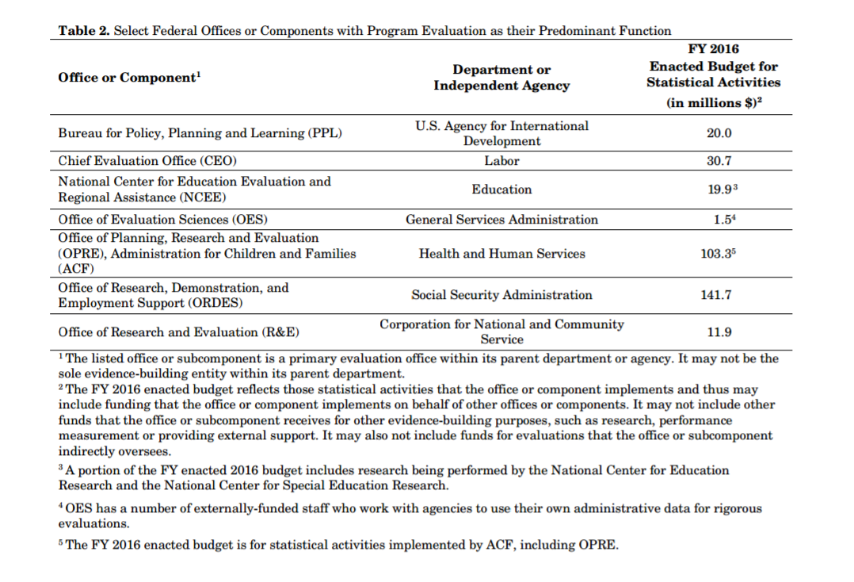

Image Source: [“[Overview of Federal Evidence-Building Efforts](https://www.whitehouse.gov/sites/default/files/omb/mgmt-gpra/overview_of_federal_evidence_building_efforts.pdf),” Office of Management and Budget, July 15th, 2016.]

#### **Learning Agenda - Deliverable 4: One or more “success stories” or learning narratives to underscore impact**

Case study profiles:

1. Department of Labor
2. Department of Education: What Works Clearinghouse

**Case 1: Department of Labor**

**Summary:**

The Department of Labor has been one of the leading agencies to adopt a robust learning agenda approach. This approach has been multifaceted and resulted in a cultural shift towards staff and programs thinking strategically about both program’s evaluation and evidence but also how staff can use data and evaluation to meet their own learning and improvement needs.

**Introducing a Chief Evaluation Officer: DOL’s Experience**

Over the last six years, the Department of Labor (DOL) has made significant progress in institutionalizing a culture of evidence and learning. The Chief Evaluation Office (CEO), established in 2010, plays a critical role in developing and maintaining this culture within DOL. As a part of its primary responsibility to manage DOL’s evaluation program, the CEO focuses on a strong commitment to conducting rigorous, relevant, and independent evaluations. CEO is also committed to identifying and funding research and evaluation priorities established through a collaborative learning agenda process with DOL’s various agencies.

These agencies cover a broad range of topics, from employment and training programs to worker protection and enforcement activities. CEO plays an important role in initiating research that cuts across these agency and program silos. CEO also serves as an “honest broker” on evidence issues within DOL, and its work is not limited to implementing evaluations. CEO actively participates in the performance management and strategic planning processes of the Department, and disseminates the results of their evaluations in formats that enable use by programs and policy makers.

Some of the key capacities that DOL developed to support this work include:

* Hiring staff with expertise to strengthen the CEO’s capacity to manage rigorous evaluations of various methodologies. For example, using behavioral insights, CEO worked with Occupational Safety and Health Administration to implement a large random assignment study that identified an effective way to support establishments that have injury and illness rates above the national average.
* Launching the Clearinghouse for Labor Research and Evaluation (CLEAR), which makes research on labor topics more accessible to practitioners, policymakers, researchers, and the public more broadly, thus increasing the transparency and relevance of the Department’s evaluation efforts.
* Implementing a learning agenda process for the Department, in which CEO collaborates with each agency to identify key evaluation and research priorities.
* Securing the budget authority to set aside a portion of specified program funds (.75% in 2016) to support these evaluations.
* Creating a data analytics unit to support and complement agencies on their analytic needs and work; build data, statistical, and analytical expertise and capacity for the Department; and promote and innovate DOL administrative and public use data.
* Establishing an [evaluation policy](https://www.dol.gov/asp/evaluation/EvaluationPolicy.htm) to institutionalize and guide the Department’s evaluation efforts.

|  |
| --- |
| **Factors for Strengthening a Learning Culture at the Department of Labor**  Reflecting on key components that drove the Department of Labor’s learning agenda approach, former Deputy Secretary, Seth Harris, identified 7 key factors—leadership commitment, set-aside funding, establishing a learning agenda, creating a Chief Evaluation Officer and office, building relationships, and connecting performance with evaluations, policy development, and creating a clearinghouse of evaluation information:  **Commitment from leadership**. The commitment of the Secretary and Deputy Secretary to build a culture of evidence and learning has been critical. That includes their support for the role of the Chief Evaluation Officer (CEO) as an "honest broker" about evidence issues; the requirement from leadership that operating agencies create learning agendas; and top leadership's inclusion of the CEO in key policy and management discussions (e.g., agency performance reviews) so that the CEO is knowledgeable about leadership's priorities.  **0.5% set aside for program evaluation.** The DOL Secretary can set aside up to 0.5% of appropriated funds from funds from specific budget accounts for evaluation. Once set aside, these funds get transferred to the Chief Evaluation Officer's budget. Many of the agencies also have separate evaluation funds, so this (up to) half percent supplements those funds.  **Learning agendas.** Learning agendas are an important planning tool at DOL. Each operating agency within the Department (there are 15) is required to create a five-year learning agenda, which gets updated every year. The learning agendas highlight priority questions and/or priority studies that the agencies would like to have done. They may also convey themes for their upcoming evaluation efforts or analysis that might be needed. They draw on a range of learning tools, including rigorous impact evaluation (i.e., randomized controlled trials or well-designed quasi-experiments), basic analysis or research, and performance analysis (looking at factors that are associated with outcomes). Learning agendas are a catalyst for setting priorities for studies and for conceptualizing studies that need to be done. Evaluations that Congress has required of agencies are also included. Importantly, the learning agendas communicate and engage operating agencies to help focus the resources and services of the Chief Evaluation Office.  **Chief Evaluation Officer (and office).** The role of the CEO is to coordinate, encourage and build the capacity and understanding around evaluation throughout the department. As noted above, the CEO's budget includes appropriated dollars for use by the CEO for evaluation, which she can then allocate to advance agencies' learning agendas. The CEO role is not designed to direct or centrally control all evaluation at DOL, but rather to encourage good evaluation. By 2016 there were approximately 50 studies underway and 30 more being planned. In 2016, the CEO was converted to a career positon to provide stability and institutionalize it within the Department.  **Building strong relationships with operating agencies around relevance of evaluation.** The Chief Evaluation Office has worked to create strong and productive relationships with the operating agencies-particularly in terms of showing that evaluation can be useful to those agencies-in at least two ways. First, they have framed their office's work around a spirit of collaboration and learning, rather than emphasizing requirements. Second, the focus of the CEO, just like the learning agendas, is primarily on learning and performance improvement, not an "up or down" verdict on particular programs. That has helped build trust with the agencies around evaluation and to see the CEO's office as useful to them.  **Connecting performance and evaluation efforts.** Performance and evaluation efforts can sometimes be siloed within Departments. DOL has been able to build bridges between these analytical approaches (and between staff in each area). In particular, the CEO also sits in all quarterly performance reviews with agencies run by the Deputy Secretary. In most meetings, there is often some discussion of evaluations underway. The CEO also provides input and assistance about existing or proposed performance measures, including identifying ways to add outcome measures or build more knowledge about whether an agency's (or program's) performance measures are correlated with impacts. That, in turn, can lead to updates to the agency's learning agenda.  **Departmental evaluation policy statement.** [The statement posted on DOL's website in 2014](http://www.dol.gov/asp/evaluation/EvaluationPolicy.htm) presents the principles that guide DOL's planning, conduct, and use of program evaluations. It emphasizes a commitment to conducting rigorous, relevant evaluations and to using evidence from evaluations to inform policy and practice. The statement also addresses the topics of rigor, relevance, transparency, independence, and ethics in the conduct of evaluations.  **Clearinghouse of evidence-based approaches.** DOL's [Clearinghouse for Labor Evaluation and Research (CLEAR)](http://clear.dol.gov/) is designed to make research on labor topics more accessible to practitioners, policymakers, researchers, and the public more broadly so that it can inform their decisions about labor policies and programs.  Source: [Harris, S., “[Innovation Exchange 2015](https://www2.ed.gov/about/offices/list/ods/evidence/innovation-exchange-2015-innovation-guide.pdf),” p. 15, Department of Education, July 10th, 2015.] |

Source: [“[Analytical Perspectives: Budget of the United States Government, Fiscal Year 2017](https://www.whitehouse.gov/sites/default/files/omb/budget/fy2017/assets/ap_7_evidence.pdf),” c. 7, Office of Management and Budget, 2016.]

**For more information**, contact[Dr. Molly Irwin](https://www.dol.gov/asp/evaluation/MollyIrwin.htm), Chief Evaluation Officer, chiefevaluationoffice@dol.gov

**To Learn More:**

[Visit the Department of Labor’s Evaluation website](https://www.dol.gov/asp/evaluation/)

[Read the Department of Labor’s Evaluation policy](https://www.dol.gov/asp/evaluation/EvaluationPolicy.htm)

[The Role of a Chief Evaluation Officer: An interview with Demetra Nightingale, Chief Evaluation Officer, U.S. Department of Labor](http://govinnovator.com/demetra_nightingale/)

**Case 2: Department of Education/Institute for Education Science What Works Clearinghouse**

When describing a “learning agenda,” OMB includes dissemination: “Develop plans to disseminate findings in ways that are accessible and useful to program officials, policy-makers, practitioners, and other key stakeholders—including integrating results into performance.” Source: [“[Analytical Perspectives: Budget of the United States Government, Fiscal Year 2017](https://www.whitehouse.gov/sites/default/files/omb/budget/fy2017/assets/ap_7_evidence.pdf),” c. 7, Office of Management and Budget, 2016.]

In the [2017 Analytic Perspectives,](https://www.whitehouse.gov/sites/default/files/omb/budget/fy2017/assets/ap_7_evidence.pdf) this process is further elaborated on in the context of clearinghouses. Clearinghouses or online depositories of information help ensure that the learnings from agencies evaluation work can be used by practitioners and policymakers beyond their own programs. The Department of Education’s Institute of Education Sciences has been producing evaluation information since its inception in the [Education Sciences Reform Act of 2002](https://ies.ed.gov/pdf/PL107-279.pdf). Responsible for running the “[What Works Clearinghouse](https://ies.ed.gov/ncee/WWC/),” their experience implementing evaluation reviews and creating a public-facing clearinghouse can be informative for other agencies or programs who wish to do so.

**Summary:**

In 2002, the [No Child Left Behind Act](https://www.gpo.gov/fdsys/pkg/PLAW-107publ110/content-detail.html) actively encouraged the adoption and funding of “scientifically based research” educational programs. However, practitioners had difficulty identifying which programs had evidence of effectiveness and what to make of the wide range of evaluation quality. With a limited time period for implementation and lacking the training to evaluate research quality, practitioners didn’t know how to source evidence-based programs as NCLB instructed. Agency staff and appropriators identified this challenge and worked to address it. As a part of the Education Sciences Reform Act, the Department of Education’s [Institute of Education Science](https://ies.ed.gov/) created the What Works Clearinghouse (WWC). An Initiative of the [National Center for Education Evaluation and Regional Assistance](https://ies.ed.gov/ncee/), the mission of the WWC is to “be a central and trusted source of scientific evidence for what works in education. [Seftor, N., “[Raising the Bar](http://journals.sagepub.com/doi/pdf/10.1177/0193841X16665023),” [Evaluation Review*,* 2016](http://journals.sagepub.com/doi/pdf/10.1177/0193841X16665023).]

WWC is now one of the longest running Federal clearinghouses and has served as a model for other searchable evidence databases like those for [Teen Pregnancy Prevention](https://www.hhs.gov/ash/oah/oah-initiatives/tpp_program/db/index.html) and [Opportunity Youth programs](http://youth.gov/evidence-innovation).

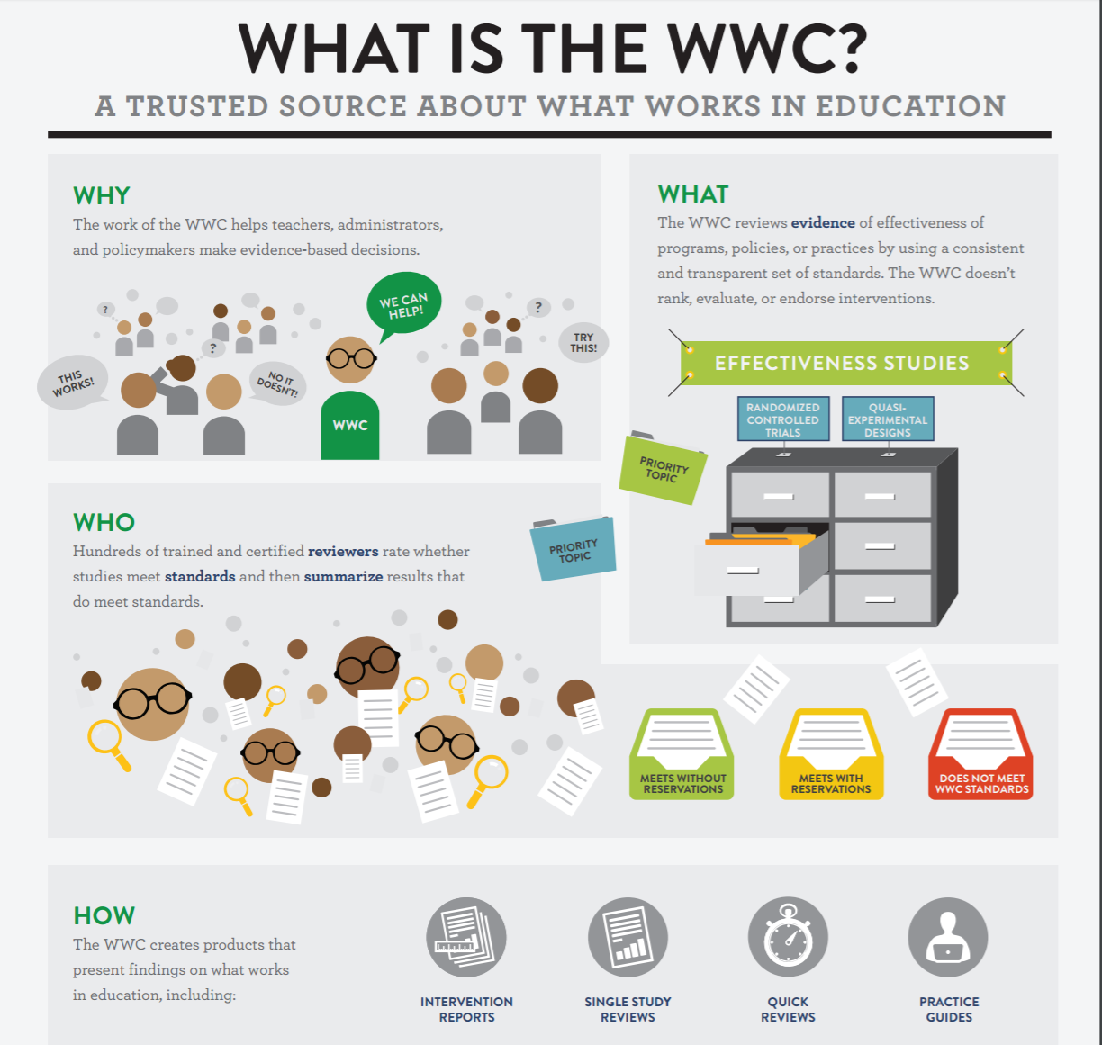

[Image Source: [What Works Clearinghouse](http://ies.ed.gov/ncee/wwc/Docs/referenceresources/wwc_info_what_061015.pdf)]

**How They Did It:**

1. Staffing and capacity building:

Use contractors to enhance capacity and capabilities to produce and run a robust clearinghouse. The contractor scope for the backbone components of the WWC included helping to set standards and review protocols, conducting reviews, synthesizing and reporting results. IES is now implementing its third 5-year contract to manage and run the WWC and has expanded to include additional contractors handling other related scopes of work.

1. Develop and implement a review process:

The WWC developed a systematic review process. This guide helped define the purpose, process, and results the WWC review strives to achieve. As several types of programs are included in the WWC, the review process allowed each to develop its own tailored protocol.

It is important to note that the bulk of the systematic evidence review process is focused on the quality, methodology, and rigor of the evaluation process - not necessarily the outcomes of the evaluations. Also, external contractors are responsible for the reviews and report writing so a detailed process was important to ensure consistency and continuity across rotating contracted staff. Studies are gathered through a comprehensive search of published and unpublished publicly available research literature using electronic databases, outreach efforts, and public submissions. Studies are also screened for eligibility against the [criteria](https://ies.ed.gov/ncee/wwc/Protocols) specified in the review protocol, and each eligible study is reviewed against WWC standards (see image below). The details of the review and its findings are summarized in a report, which may synthesize findings from multiple studies. Reports cover students from pre-kindergarten through postsecondary schooling and span a range of education topics, including academic achievement, behavior, and progress through school, as well as programs targeting specific populations, such as students with learning disabilities and English language learners.

**Determinants of a WWC Rating**

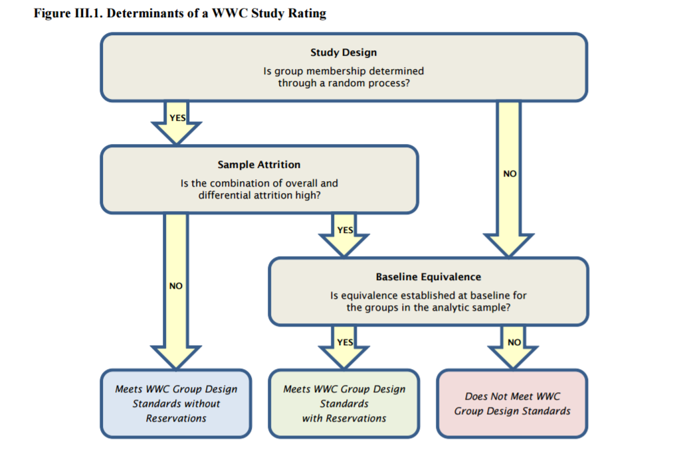

Image Source: [“[Procedures and Standards Handbook Version 3.0](https://ies.ed.gov/ncee/wwc/Docs/referenceresources/wwc_procedures_v3_0_standards_handbook.pdf)”, What Works Clearinghouse, March 2014.]

For further reading on the WWC review protocol, see “[Raising the Bar](http://journals.sagepub.com/doi/pdf/10.1177/0193841X16665023).” [Seftor, N., “[Raising the Bar](http://journals.sagepub.com/doi/pdf/10.1177/0193841X16665023),” [Evaluation Review*,* 2016](http://journals.sagepub.com/doi/pdf/10.1177/0193841X16665023).]

The WWC currently produces four types of reports based on reviews of studies:

1. **Intervention reports** summarize the findings of the highest quality research that examines the effectiveness of a program, practice, or policy in education.
2. **Practice guides** contain practical recommendations that educators can use to address specific challenges in their classrooms and schools.
3. **Quick reviews** are brief, timely assessments of education research garnering notable mention in the press.
4. **Single study reviews** are evaluations of individual research studies of IES-funded studies and studies submitted in support of applications for grants (e.g., [i3](https://www2.ed.gov/programs/innovation/index.html) and [School Improvement Grants).](https://www2.ed.gov/programs/sif/index.html) The results of these reviews are made public but official reports aren’t created for these.
5. Review, Revise, Repeat

The protocols for evaluation reviews, including the definition of ratings, were collected into a [handbook](https://ies.ed.gov/ncee/wwc/Protocols) in 2008. It has since been revised three times to reflect changes in standard, revised procedures, and provide clarifications, taking into account lessons learned after running more than 10,000 studies through this protocol. As of December 2014, the WWC has conducted systematic reviews for 568 intervention reports [Seftor, N., personal correspondence with Policy Design Lab, January 13th, 2017.] To create these reports, the WWC processed 8,125 studies through its literature search [Seftor, N., “[Raising the Bar](http://journals.sagepub.com/doi/pdf/10.1177/0193841X16665023),” [Evaluation Review*,* 2016](http://journals.sagepub.com/doi/pdf/10.1177/0193841X16665023).]

**Insights from Implementation:**

Neil Seftor, Deputy Director at the WWC and Senior Researcher with Mathematica, identified several challenges in implementing the program [Seftor, N., phone interview with Policy Design Lab, December 6th, 2016.]

Limited Supply for the Clearinghouse Market

One issue that the WWC encountered was the relative lack of available rigorous research program effectiveness in the education field. In the first few years of the WWC reviews, 23% of studies met the WWC criteria [Seftor, N., “[Raising the Bar](http://journals.sagepub.com/doi/pdf/10.1177/0193841X16665023),” [Evaluation Review*,* 2016](http://journals.sagepub.com/doi/pdf/10.1177/0193841X16665023).] This number has steadily gone up as studies submitted are increasingly meeting the review criteria. According to the RCTs conducted by IES, 12% of evaluations showed projects produced positive impacts [Seftor, N., “[Raising the Bar](http://journals.sagepub.com/doi/pdf/10.1177/0193841X16665023),” [Evaluation Review*,* 2016](http://journals.sagepub.com/doi/pdf/10.1177/0193841X16665023).] While this is in line with other sectors who rely on rigorous evaluation, for a clearinghouse hoping to promote and encourage adoption of effective programs, this number of effective interventions is disappointingly low.

Limited Awareness for Clearinghouse Products

The WWC is evolving and aims to provide resources for policy makers, practitioners, and funding organizations—from philanthropic to individual school districts. The WWC is still struggling to accomplish this objective. User information and the extent to which external groups use the WWC has been hard to identify. In the beginning, staff across the Department of Education were not that familiar with the WWC or its definitions and protocols [Seftor, N., phone interview with Policy Design Lab, December 6th, 2016] though with the implementation of tiered-evidence grantmaking this has changed and now the role of the WWC has expanded throughout agency programs. While traffic to the WWC website has increased, and usability has improved greatly with a recent redesign, it is not yet clear if users, such as external evaluators or private philanthropy, are fully leveraging the potential value of the knowledge base curated by the WWC.

**For more information,** contact the What Works Clearinghouse Help Desk: (866) 503-6114

**Read more:**

[What Works Clearinghouse Website](http://ies.ed.gov/ncee/wwc/FWW)

[What Works Clearinghouse Glossary of Terms](http://ies.ed.gov/ncee/wwc/Glossary)

[Results for America “What Works Marketplace” summary policy report](http://results4america.org/tools/works-marketplace-helping-leaders-use-evidence-make-smarter-choices/)

[Results for America commissioned report on “What Works Marketplaces”](http://results4america.org/wp-content/uploads/2015/04/WhatWorksMarketplace-vF-1.pdf)

[Report on IES randomized control study findings](http://coalition4evidence.org/wp-content/uploads/2013/06/IES-Commissioned-RCTs-positive-vs-weak-or-null-findings-7-2013.pdf)

#### **Learning Agenda - Deliverable 5: Challenges to deployment / approach limitations for implementing a Learning Agenda**

Implementing a learning agenda across or within agencies can be challenging. Conversations and research regarding the implementation of learning agenda strategies revealed similar important lessons that can be useful to agencies seeking to implement these strategies themselves. Based on the experiences at the Corporation for National and Community Service, USAID, Department of Labor, and Department of Education’s WWC, consider the following five ingredients for success:

* **Establish consistent evidence vocabulary, then teach it and use it**
* **Ensure sustained expert leadership to drive the charge**
* **Think strategically about creating culture change**
* **Embed evidence and evaluation within programs**
* **Generate cross-government or senior leadership support**

1. **Establish consistent evidence vocabulary, then teach it and use it**

The issue of evaluation vocabulary and translation is an ongoing challenge when implementing a strategic push towards evidence-based practice. It is important for agencies to define “evidence” and “evaluation.” Based on the program focus or sector, there may be a different expectation for what is authoritatively understood as a high quality, valid evaluation. Or there may be a range of definitions: one reflecting a less rigorous understanding used by practitioners and one the more rigorous definition an agency is striving towards.

“Effectiveness” or “what works” is another definition that will need to be clarified. For example, “best practices” is often thrown about to mean effective ways of tackling a specific problem or challenge but rarely are the practices entitled “best” vetted by rigorous scientific evaluation. Similarly, the definition of “what works” may need to specify “for whom” an intervention works and “under what circumstances.” These semantics will need to be carefully teased apart. As one practitioner cautioned, “if you come in saying ‘I’m for evidence, and we want to only invest in evidence-based programs defined this way...you’ve essentially just told your agency colleagues that what they have been doing, sometimes for decades, is not good enough and not effective. Be thoughtful about your language so you don’t end up burning bridges.” [Healy, A., phone interview with Policy Design Lab, December 16th, 2016.]

**2) Ensure that there is sustained expert leadership to drive the charge**

In order to help explain and implement an evidence-based learning agenda across a department or agency, it is important to have expertise on hand who can help lead the charge and to position that expertise in a part of the organization that has a cross-cutting, agency-wide mandate. In some agencies, the first step was to establish a Chief Evaluation Officer. In others, it was to task an existing Director of Research and Evaluation to take on this role. The proper title and placement of such a person will vary depending on the agency but one thing seems unanimously voiced - the person must have the full support of leadership and be empowered to work alongside deputies and program directors to ensure a true adoption of evidence or data-based decision making occurs.

**3) Think strategically about creating culture change**

Implementing culture change requires pressure (and cover) to ensure it happens. It can be a painful process to disrupt the status quo. The effort behind advancing the evidence-based policy agenda is akin to turning around a massive ship, according to Neil Seftor, project director for the What Works Clearinghouse; it will take time, energy, incentives, and a lot of manpower to achieve a complete change. [Seftor, N., phone interview with Policy Design Lab, December 6th, 2016.]

Think in the short and long term, advises Chris Spera, formerly at the [Corporation for National and Community Service (CNCS)](http://www.nationalservice.gov). [Spera, C., phone interview with Policy Design Lab, November 30th, 2016.]

The evaluation team at CNCS thus planned out projects or initiatives that could achieve early wins - along a six month, 1 year and 2 year calendar. “Most of our evaluations are on a 3 to 5 year study period. You can’t ask colleagues to wait that long to see your value. Our early wins helped keep momentum going.” [Spera, C., phone interview with Policy Design Lab, November 30th, 2016.]

“You have to understand where different staff are coming from and use different types of engagement techniques,” advises Anne Healy, who leads [Development Innovation Ventures](https://www.usaid.gov/div) at USAID. [Healy, A., phone interview with Policy Design Lab, December 16th, 2016.] “Some people will respond to the scientific appeal of evidence-based decision making. Others might be responsive if they see their leaders being responsive. Others may focus may focus more on relationships and be open to discussion only after multiple conversations where you listen to what they do and what their concerns and needs are and then show how evidence and evaluation can help address these. You have to use multiple forms of influence for this to really be embraced as a cultural shift,” she adds. [Healy, A., phone interview with Policy Design Lab, December 16th, 2016.]

**4) Embed evidence and evaluation within programs**

Traditionally, evaluation and research shops have worked fairly siloed from programmatic shops. This can be a strength when ensuring independence of the program evaluation offices and staff, but it can be a deterrent for diffusing an evidence-based learning agenda approach across an agency. Both CNCS and DOL highlight a successful effort to build relationships between the evaluation or research office and the program offices, and both noted the importance of outreach and relationship building between the two staff to achieve this.

At CNCS, the Director of Research and Evaluation tasked his staff to work with program staff to collaboratively plan their own assessment agendas. The teams were already working collaboratively on grant decisions because of newly added agency evidence policies. Getting evaluators into team meetings to ask “*What do you want to know? What would be helpful in meeting your own performance goals?”* helped illustrate how the work was valuable to the program officers in the weekly monitoring of their portfolios. It helped demonstrate that this was not an “add on” to an already large “to do list,” but a way of helping re-prioritize and organize the support they provided to their grantees [Spera, C., phone interview with Policy Design Lab, November 30th, 2016.]

**5) Generate cross-government or senior leadership support**

Practitioners observed that cross-agency or even cross-department learning was a challenge, but the evidence-based policy agenda benefits from centralized support and coordination. For instance, if there is a call for a single coordinated set of definitions of what “strong” evidence means or what constitutes “high” versus “low” evidence ratings, empowering a facilitator with decision-making authority can coordinate and generate consensus.

Agencies may have a hard time reaching cross-agency consensus, as each may prefer authority to make their own decisions on definitions and policy language, and each have their own programmatic goals and objectives. However, “There needs to be a high-level, neutral entity working to identify who should be at the table, convening the table, and driving discussions,” advises Neil Seftor: “Otherwise this work just won’t get done...it won’t be prioritized.” [Seftor, N., phone interview with Policy Design Lab, December 6th, 2016.]

#### **Learning Agenda - Deliverable 6: How-To: Steps for deploying, practices for adapting**

Agencies or programs should assess where they are in terms of creating and implementing a learning agenda. Their approach for next steps will depend on if they fall towards the beginning, middle or end of the evidence-based practice continuum.

**At the outset**:

If you are just beginning to implement evidence-based policy, consider the tactics undertaken by [DOL and CNCS](#_Learning_Agenda_-):

* Start by asking what questions do you have about your program or topic area that would be helpful to answer.
  + Conduct conversations and/or create a survey that can be used by program and leadership staff to ascertain key questions about a program’s performance. Add any program questions you may have received from OMB examiners or congressional staff.
* Review the questions and determine the best method for answering these questions. This should include:
  + What is the appropriate and more rigorous evaluation design or method to answer this question?
  + What data do you need to answer the question?
  + What is your timetable for answering the questions?
  + Who is best situated to provide the data you need (i.e. grantees, beneficiaries, evaluators, program staff, etc.)
* Create strategies for data collection and reporting.
  + Develop new or refine existing performance reporting to collect identified data points
  + Develop and implement a program evaluation
  + Manipulate existing data sets to produce useful reports that can be used for decision making
* Distribute and review results, and ensure they are used.
  + Provide reports or briefings that are easily used by the targeted audience (e.g. technical reports may be appropriate for an evaluation office, summary reports with infographics or other visuals may be appropriate for program staff or grantees)
  + Provide technical assistance to ensure audiences can interpret and act on the data provided
  + Model effective and transparent use of data and evaluation – communicate how programs or policies are proactively changing in response to reports

**Experienced Practitioners:**

For programs that are already employing evidence-based programs, consider how you can enhance the rigor of evaluations and expand use of evaluation results. For example, if a program has been implemented for a few years with positive performance data, consider engaging an external evaluator to conduct and impact evaluation. Promote lessons learned from all evaluations to both internal and external audiences, modeling an emphasis on learning and improvement.

**Shared Considerations across the evidence-based policy continuum**

These considerations will apply to all programs, regardless of whether they are just starting or building on existing efforts.

1. Staffing and Capacity

Assess the agency’s evaluation needs and most appropriate methodologies for meeting these needs. Then assess the existing evaluation capacity and expertise. It may be that there is a mismatch of needs and capacity. If this is the case, explore various means of recruiting the expertise or talent needed. This can be through traditional new hires, details from other departments or agencies, or using technical assistance contracts. The staffing path will depend on a given agency’s staffing and contracting budget.

1. Assess access to funding

Review budget authority and regulations to determine if it is possible to use existing funding to support evaluations. Several agencies have either budget or statutory authority to set aside a percentage of funding for the purpose of evaluation. [Ayers, J., personal communication with Policy Design Lab, January 13th, 2017.] If there is a history of this set-aside not being used, explore why and if there is a way to take advantage of it going forward. This is likely to be a delicate conversation as program staff may be defensive of any dollars being diverted from programming.

Examples of Departmental set asides include:

1. Department of Labor’s universal set-aside for the CEO office (.75% of almost all programs);
2. Department of Education’s set-aside of .5% of all ESEA (K-12) programs; and
3. Administration for Children and Families’ set-aside of .5% of Child Care and Development Block Grant funds.) [Ayers, J., personal communication with Policy Design Lab, January 13th, 2017
4. Plan out short and long term milestones

Work with program staff to identify meaningful intermediate outcomes or learnings and embed these into strategic plans with “early wins” identified. This could include short term milestones with interim program outcomes and long term milestones that look at overall effectiveness or outcomes that require longer time periods to capture and measure.

1. Plan and implement strategies for building support

As you begin implementation, brainstorm several approaches for building internal support and adoption of evidence-based practice. Successful programs used both leadership directives (top-down) and relationship building and educational efforts (bottom-up) to gain traction. Have “hearts and minds” approaches ready that can demonstrate the value of evidence-based policies to your agency’s beneficiaries, program staff, leadership, and oversight entities.

#### **Learning Agenda - Deliverable 9: Future directions (“next practices as opposed to best practices”)**

#### One of the key concerns regarding the promotion of evidence-based policy is the current lack of a robust evaluation library. A key contributing factor to this has historically been cost and access to data needed for rigorous evaluations. The Commission on Evidence-Based Policymaking (CEP) was established by the bipartisan [Evidence-Based Policymaking Commission Act of 2016](https://www.gpo.gov/fdsys/pkg/BILLS-114hr1831enr). This commission is focused on expanding access to data needed to conduct rigorous evaluations. The members are exploring several key issues related to the use of survey and administrative data, with recommendations expected to be issued in Fall 2017:

* Existing barriers to accessing and using data government already collects
* Strategies for better integrating existing data with appropriate infrastructure and security, to support policy research and evaluation
* Practices for monitoring and assessing outcomes of government programs
* Whether a data clearinghouse could enhance program evaluation and research opportunities

**Read more** about the [Commission on Evidence-Based Policymaking](https://www.cep.gov/about.html).

#### **Learning Agenda - Deliverable 8: Examples of policy that have enabled or encouraged approach (legislation, exec order)**

Legislation:

[H.R. 1831 - Evidence-Based Policymaking Commission Act of 2016](https://www.congress.gov/bill/114th-congress/house-bill/1831)

Policy Guidance:

“[Increased Emphasis on Program Evaluations](https://www.whitehouse.gov/sites/default/files/omb/assets/memoranda_2010/m10-01.pdf).” OMB M-10-01. Oct 7 2009.

“[Next Steps in the Evidence and Innovation Agenda](https://www.whitehouse.gov/sites/default/files/omb/memoranda/2013/m-13-17.pdf).” OMB M-13-17. Jul 26 2013.

“[Analytical Perspectives: Budget of the United States Government, Fiscal Year 2017](https://www.whitehouse.gov/sites/default/files/omb/budget/fy2017/assets/ap_7_evidence.pdf).” c. 7. Office of Management and Budget. 2016.

See also:

[Policy Brief on State and Federal Evidence-Based Legislation](http://www.pewtrusts.org/~/media/assets/2015/03/legislationresultsfirstbriefmarch2015) (Pew/MacArthur Results First Initiative, 2015)

#### **Learning Agenda - Deliverable 7: Online inventory of resources**

**Communities of Practice:**

The Science of Science Policy Interagency Working Group (IWG) was established in 2006 by the National Science and Technology Council. In 2008, the IWG published a [roadmap](http://cssip.org/docs/meeting/science_of_science_policy_roadmap_2008.pdf) that outlined recommendations to advance evidence-based science and innovation policy. The IWG continues as an informal community of interest, led by the National Science Foundation, and is focused on ways to improve administrative data on research awards across Government and the non-Federal evaluation community.

For more information on the Science of Science Policy IWG, contact Maryann Feldman, NSF, [mfeldman@nsf.org](mailto:mfeldman@nsf.org)

Resources

* [Results for America](http://results4america.org/),
* [Arnold Foundation’s Evidence-Based Policy Innovation Initiative](http://www.arnoldfoundation.org/initiative/evidence-based-policy-innovation/)
* Archive for [Coalition for Evidence-Based Policy](http://coalition4evidence.org/) (now based at Arnold Foundation)
* [Evidence-Based Policymaking Collaborative](http://www.evidencecollaborative.org/toolkits/low-cost-randomized-controlled-trials)

Books

* Nussle, J., and Orszag, P., “[Moneyball For Government](http://moneyballforgov.com/moneyball-for-government-the-book/),” Disruption Books, 2015.
* Haskins, R. and Margolis, G., “[Show Me the Evidence](http://www.brookings.edu/research/books/2014/show-me-the-evidence),” Brookings Institution Press, 2014.

**Multimedia content:**

[Gov Innovator Podcast](http://govinnovator.com/): Conversations on evidence-based policy from public sector innovators and experts, hosted by Andy Feldman, a Visiting Fellow at the Brookings Institution and former Special Advisor for Evidence-Based Policy at OMB:

* [Important tools for evidence-based decision making](http://govinnovator.com/margery_turner/): Margery Turner, Urban Institute
* [How one Federal agency, the Corporation for National and Community Service (CNCS), strengthened the role of evidence in a key grant program, AmeriCorps](http://govinnovator.com/americorps/): Diana Epstein and Carla Ganiel, CNCS
* [Insights for evidence-based grant making from the Teen Pregnancy Prevention Program](http://govinnovator.com/evelyn_kappeler/): Evelyn Kappeler, U.S. Department of Health and Human Services
* [The Federal evidence agenda and lessons for state and local leaders](http://govinnovator.com/ron_haskins/): Ron Haskins, Brookings Institution
* [Becoming an evidence focused grant-making organization](http://govinnovator.com/kelly_fitzsimmons/): Kelly Fitzsimmons, Edna McConnell Clark Foundation
* [Building an evidence base for agency programs](http://govinnovator.com/chris_spera/): Chris Spera, Corporation for National and Community Service
* [Harnessing Silicon Valley funding approaches to drive breakthrough solutions in the public sector](http://govinnovator.com/jeffrey_brown/): Jeffrey Brown, U.S. Agency for International Development (USAID)
* [Strengthening evidence-based grant making at the U.S. Department of Education](http://govinnovator.com/jim_shelton/): Jim Shelton, Deputy Secretary of Education

**Watch:**

* [“How to create a culture of evidence in your community/organization”](https://www.whitehouse.gov/sites/default/files/video/mbk_webinar_recording_52516.mp4" \t "_blank)
* “[Identifying and Contributing to "What Works,"](https://www.whitehouse.gov/sites/default/files/video/Webinar_Recording_062216.mp4" \t "_blank)
* [“Evaluation and Evidence-Based Decision-Making”](https://www.whitehouse.gov/sites/default/files/video/webinar_recording_7.20.16.mp4" \t "_blank)
* [“Innovative Funding Models to Advance “What Works”](https://www.whitehouse.gov/sites/default/files/video/webinar_recording_8.17.16.mp4" \t "_blank)

**Additional specific resources:**

Related topics, including evidenced-based policy, program evaluation, and research design:

* [Five Steps to Building an Evidence-Based Culture in Government](http://www.businessofgovernment.org/blog/business-government/five-steps-building-evidence-based-culture-government)
* [Child Trends Brief on Performance Management](http://www.childtrends.org/wp-content/uploads/2013/06/2011-02PerformMgmt.pdf)
* [U.S. Department of Education: Guide for recognizing and conducting opportunistic experiments:](http://ies.ed.gov/ncee/pubs/REL2014037/pdf/REL_2014037.pdf)
* [Key Items to Get Right When Conducting a Randomized Controlled Trials of Social Programs](http://www.arnoldfoundation.org/wp-content/uploads/Key-Items-to-Get-Right-When-Conducting-Randomized-Controlled-Trials-of-Social-Programs.pdfhttp:/www.arnoldfoundation.org/wp-content/uploads/Key-Items-to-Get-Right-When-Conducting-Randomized-Controlled-Trials-of-Social-Programs.pdf)
* [Using Evidence-Based Approaches to Improve Program Performance](http://www.napat16.org/images/EvidenceBasedRecsFINAL.pdf)
* [**Rigorous Program Evaluations on a Budget: How Low-Cost Randomized Controlled Trials Are Possible in Many Areas of Social Policy**](http://coalition4evidence.org/wp-content/uploads/2012/03/Rigorous-Program-Evaluations-on-a-Budget-March-2012.pdf)
* [Social Innovation Fund Evaluability Assessment Tool](https://www.nationalservice.gov/sites/default/files/resource/SIF_Impact_Evaluability_Assessment_Tool_Final_Draft_for_Distribution.pdf)

**Additional articles and references**

Keegan, M., “[Invest in What Works: A Conversation with John Bridgeland and Bruce Reed](http://www.businessofgovernment.org/blog/business-government/invest-what-works-conversation-john-bridgeland-and-bruce-reed),” IBM Center for the Business of Government, April 22nd, 2016.

Bornstein, D., “[The Dawn of the Evidence-Based Budget](https://opinionator.blogs.nytimes.com/2012/05/30/worthy-of-government-funding-prove-it/?_r=2),” New York Times, May 30th, 2012.

“[Evidence-Based Policymaking: A Guide for Effective Government](http://www.pewtrusts.org/en/research-and-analysis/reports/2014/11/evidence-based-policymaking-a-guide-for-effective-government).” Pew-MacArthur Results First Initiative, November 13, 2014.

**Pay for Success: Public and Private Partnerships to Drive Evidence-Based Investment**

Pull quote:

“Pay for Success is an innovative way of partnering with philanthropic and private sector investors to create incentives for service providers to deliver better outcomes at lower cost—producing the highest return on taxpayer investments. The concept is simple: pay providers after they have demonstrated success, not based on the promise of success, as is done now.”

[“[Paying for Success: Federal Budget Fiscal Year 2012](https://www.whitehouse.gov/omb/factsheet/paying-for-success),” Office of Management and Budget, 2012.]

### **PFS - Deliverable 1: Elevator pitch summary**

Pay For Success is a means of promoting evidence-based programs at the local, state, and Federal level to achieve outcomes and pay for them in a more cost-effective way. It may be understood as a new type of financing model, a new form of outcomes-focused contract, or a new approach to public-private partnership.

“Pay for Success refers to a performance-based contract between government agencies and service providers, with the government paying only if the provider generates results,” notes [Results for America](http://results4america.org/), a nonpartisan advocate of the approach. [“[Invest in What Works: Pay for Success Factsheet](http://results4america.org/tools/invest-works-pay-success/),” Results for America, August 18th, 2015.] “Under a Pay for Success (PFS) deal, also known as Pay-for-Performance or Social Impact Bonds, a government agency enters into a contract with an intermediary organization to achieve specific outcomes that will produce government savings. The contract specifies how results will be measured and the level of outcomes that must be achieved for government to make payments. The intermediary selects one or more service providers to deliver a proven or promising intervention expected to produce the desired outcomes. Funding for service delivery comes from outside investors, often secured by the intermediary. If the desired outcomes are achieved, then government pays the intermediary, which in turn pays investors.” [“[Invest in What Works: Pay for Success Factsheet](http://results4america.org/tools/invest-works-pay-success/),” Results for America, August 18th, 2015.]

While simple in concept, the contracting and financing involved is complicated. GAO developed the following infographic to help illustrate partners and funding flow in the pay for success model. To date, at least six different agencies are implementing some form of Pay for Success project.

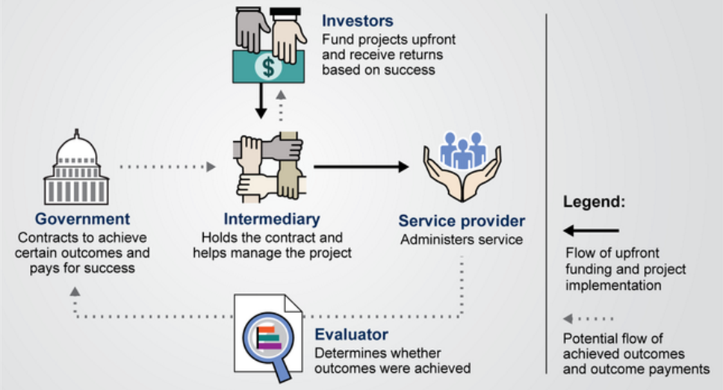

# [“[Pay for Success: Collaboration among Federal Agencies Would be Helpful as Governments Explore New Financing Mechanisms](http://www.gao.gov/products/GAO-15-646),” US Government Accountability Office, September 9th, 2015.]

### **PFS - Deliverable 2: Summary of underlying rationales / empirical research**

In the context of restricted Federal spending and intractable social needs, Federal officials along with philanthropists and impact investors have been exploring Pay for Success models as a potential solution. Pay for Success programs are outcomes- and evidence-based investments. They allow an agency to invest specifically in an issue area where they hope to move the needle by achieving positive outcomes and then scaling interventions that have demonstrated impact. [Fogel, A., phone interview with Policy Design Lab, December 12th, 2016.]

Pay for Success contracts transfer risk, as the government payor only pays proportionally for the level of outcomes achieved. If the service provider is not able to achieve these outcomes, the outside investors are on the hook for program costs incurred, notes Anna Fogel, director at Social Finance and previous program manager for SIF’s Pay for Success. [Fogel, A., phone interview with Policy Design Lab, December 12th, 2016.]

Finally, the structured nature of Pay for Success arrangements create an avenue for investing in multi-year collaborations. Pay for Success contracts are inherently several years-long to allow time for recruitment of participants, implementation of the service intervention, and evaluation to measure and validate the outcomes. Interventions are rarely shorter than one year. For this reason, agencies interested in participating in long-term collaborations may find Pay for Success attractive, as the financing mechanism creates a pathway for investing beyond a given budget year, administration term, or election cycle without interrupting commitments to partners. [“[Paying for Success: Federal Budget Fiscal Year 2012](https://www.whitehouse.gov/omb/factsheet/paying-for-success),” Office of Management and Budget, 2012.]

#### **PFS - Deliverable 3: Profiles of major cats of candidate users - examples of when to deploy**

[Pay for Success literature](https://ssir.org/up_for_debate/article/the_payoff_of_pay_for_success) and advocates frequently make the same cautionary statement: Pay for Success is not appropriate for all contexts. [Rangan, V.K. and Chase, L., “[The Payoff of Pay-for-Success](https://ssir.org/up_for_debate/article/the_payoff_of_pay_for_success),” Stanford Social Innovation Review, Fall 2015.] Not all challenges will fit with the measurement and evaluation requirements for this model of outcomes-based contracting. Additionally, the partnerships required take time to develop and must all be met to ensure success - at the government level, the financier level, the service-provider level, and the evaluation level. [crosslink V5 – collective impact]

Common programmatic elements from agencies implementing some form of Pay for Success include:

* Budgetary authority or flexibility to attempt these
* Access to expertise via Technical Assistance contracts or internal staffing
* Agency focus on an issue that lends itself well to Pay for Success
  + It’s defined and measurable - both in terms of outcomes and specific costs.
  + There are interventions with evidence of effectiveness existing that achieve the desired outcomes.

As of January 2017, fifteen PFS programs have launched. Only a handful of transactions have come to fruition, with mixed results in terms of achieving the outcomes specified by contract. From an operational standpoint, these deals worked as intended; they established a contract to finance and support the implementation of an evidence-based intervention, evaluated the outcomes of this intervention, and used outcomes to learn more about its effectiveness and further scaling.

There has been significant Federal support for the piloting of Pay for Success projects, which has been matched by support and interest from private philanthropies and city and state governments as well. Federal programs have granted funds that have been used to provide technical assistance to PFS participants – existing and future. Federal funds have also been used to pay for feasibility studies, evaluations, and to support transactional costs. More recently, several Federal programs have also contracted for outcomes as well including Pay for Success initiatives at Department of Labor, a collaborative project between Veterans Affairs and the CNCS, and a partnership between HUD and DOJ:

|  |
| --- |
| **Federal Pay for Success Funding Activities**  **Social Innovation Fund (SIF)**: Program of the [Corporation for National and Community Service](http://www.nationalservice.gov/programs/social-innovation-fund/our-programs/pay-success) that has used tiered-evidence approach to award more than $240 million in funding for program expansion and evaluation in communities across the country since 2010; 2014 and 2015 appropriations included up to $21.7 million to support [development of PFS projects](http://www.nationalservice.gov/programs/social-innovation-fund/our-programs/pay-success#grantees).  **Education**: [Investing in Innovation Fund (i3)](http://www2.ed.gov/programs/innovation/index.html) supports expansion of in programs with demonstrated impact in improving secondary and post-secondary achievement; both the House of Representatives and Senate approved the inclusion of PFS initiatives as an allowable use of state and local funds in various titles of their respective versions of the Every Student Succeeds Act of 2015.  **Housing and Urban Development**: In 2015 HUD issued a [Request for Proposal](http://portal.hud.gov/hudportal/HUD?src=/program_offices/administration/grants/fundsavail/nofa2015/pfspshdemo), using funding from the [Department of Justice](https://www.bja.gov/ProgramDetails.aspx?Program_ID=90), for PFS projects that use supportive housing to improve outcomes for formerly incarcerated individuals upon reentry.  **Workforce Development**: The [Workforce Innovation Fund](https://www.doleta.gov/workforce_innovation/) provides grant funds to projects with evidence-based approaches, including [two early PFS projects](http://www.dol.gov/newsroom/releases/eta/eta20131936); the [2014 Workforce Innovation and Opportunity Act (WIOA)](https://www.doleta.gov/wioa/Overview.cfm) authorizes states and local workforce investment boards to invest up to 10 percent of funds in PFS projects.  [Directly sourced from “[Pay for Success Learning Hub](http://www.payforsuccess.org/learn-out-loud/pfs-101),” Nonprofit Finance Fund, 2016.] |

**PFS - Deliverable 4: One or more “success stories” or learning narratives to underscore impact**

**PFS Transaction Case Focus: Utah High Quality Preschool Program**

The Utah High Quality Preschool Program was launched and had its first successful payout in 2013. This PFS initiative was built on a pilot study that showed 33 percent of low-income students in Utah would likely need special education services during their primary school years [Stewart, K., “[Utah Public Preschool Push gets $7 Million from Private Investors](http://www.uw.org/news-events/news-articles/2013/utah-public-preschool-push.html),” Salt Lake Tribune, June 14th, 2013.] The project hypothesized that if at-risk students participated in preschool programs, the number of students requiring special education would decrease, creating a cost savings to the government by decreasing costs associated with providing special education services.

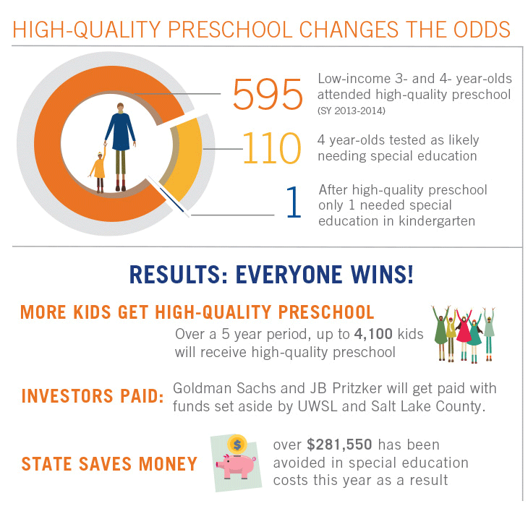

[“[Pay for Success: We’re seeing BIG Progress](http://www.uw.org/our-work/cradle-to-kindergarten/pay-for-success.html?referrer=https://www.google.com/)!,” United Way of Salt Lake, 2016.]

The key partners for this Pay for Success deal include:

* Intermediary: United Way of Salt Lake serves as the intermediary for this project, responsible for the overall implementation of the project and for managing repayments to the lenders. Utah has established a separate Performance Account Manager, under the auspices of the Park City Community Foundation, responsible for holding the repayment funds in a performance account and then distributing repayments as appropriate.
* Service Providers: The Granite School District, Park City School District, Guadalupe School, YMCA of Northern Utah, Children’s Express, and Lit’l Scholars are providing the program services to low-income three- and four year-olds.
* Project Coordinator: Voices for Utah Children, a nonprofit child advocacy group, is providing research and analytic support.
* Funders/investors: Goldman Sachs and the J.B. and M.K. Pritzker Family Foundation are the primary investors for the initiative, providing loans of $4.6 million and $2.4 million respectively.
* Evaluator: Utah State University’s Early Intervention Research Institute is the third-party evaluator.

How is Success Defined?

Success is defined in terms of a child’s use or non-use of special education or remedial services each year between kindergarten and grade 6 (K-6); each year that a student does not use a special education or remedial service will generate a PFS payment.

Did It Work?

A [review from an independent evaluator](http://www.payforsuccess.org/sites/default/files/sibfactsheet10-1-2015finaledits-4.pdf) showed that, of the 110 students who were identified as at-risk, only one used special education services in kindergarten. Investors received a payment equal to 95 percent of the State savings for avoided special education services. The 110 students will continue to be monitored through 6th grade, generating further success payments based on the number who avoid use of special education in each year.

**Read more**:

[Stanford Social Innovation Review article on the project’s success](https://ssir.org/articles/entry/pay_for_success_is_working_in_utah)

**PFS -Deliverable 5: Challenges to deployment / approach limitations**

Challenges to Pay for Success deployment include:

* Complexity of implementation
* Capacity and expertise constraints
* Limited pipeline of candidates
* Problem of addressing the “Wrong Pockets”

1. **Complexity of implementation**

One of the critiques of Pay for Success is that it is a complicated approach to implement. It is asking government funding streams to flex in a way they haven’t before. To actually participate as a funder, Federal programs would have to change existing procurement procedures to contract for outcomes, enter into contracts with multiple parties, be able to obligate funds for expenditure 2 to 5 years later, and support specific service-providing programs that are evidence-backed and subject to rigorous vetting as opposed to programs selected via formula or traditional competitive means. To be successful, staff from counsel’s offices, procurement, budget, finance, policy, evaluation and program offices all must work together. This, in itself, is a new way of doing business for many agencies and programs.

But, as Anna Fogel at Social Finance observed, in addition to these challenges, significant time is often needed to negotiate the components of the Pay for Success deal. [Fogel, A., phone interview with Policy Design Lab, December 12th, 2016.] Solid cost-benefit analysis generally supports the named outcomes and values and all parties (payors, funders, and program implementers) must agree to these. Once agreed to, intermediaries must work closely with the government entity to ensure it can enter into the contract – addressing any policy or procedural barriers and making sure that key representatives can and will sign off on the outcomes and negotiated prices. [Fogel, A., phone interview with Policy Design Lab, December 12th, 2016.]

**2) Capacity and expertise constraints**

Given the complicated nature of PFS transactions, and its divergence from the typical Federal way of doing things, it should not be surprising that another challenge posed by PFS is ensuring the necessary expertise within government agencies. Valuation and deal transactions are skill sets more likely found on Wall Street, not within an agency’s traditional civil service pool. Additionally, evaluation expertise and the ability to synthesize and integrate data and evaluation findings is not typical for program or contracting staff to have. To staff PFS programs, agencies have been hiring from the small pool of PFS insiders – people who have had experience working for intermediaries, city or state governments participating in PFS, or academic and private sector shops who are supporting PFS through research and evaluation. The specific nature of these new hires expertise make them valuable but also increases the importance of retaining them and ensuring a sustainability plan is in place to keep PFS programs running should they leave service.

**3) Limited pipeline of candidates**

The pipeline of evidence-based programs that document positive, measurable outcomes is limited. This has been [identified as an issue](http://results4america.org/wp-content/uploads/2015/04/WhatWorksMarketplace-vF-1.pdf) facing evidence-based policy measures across the board but it is particularly important in the PFS field. In order to convince investors that their bet is a good one, service-programs need to not only be able to demonstrate that they likely will achieve the outcomes promised but also be able to put a dollar figure on these outcomes. There are very few social dilemmas facing our nation to date that lend themselves readily to this type of cost-benefit analysis – that have interventions that have been both well-tested and whose preventative outcomes have cost-savings easily attributed.

4) **Problem of addressing the “Wrong Pockets”**

Since initial Pay for Success discussions began among Federal agencies in 2011, one frequent challenge has been a disconnect between investment and outcomes from an agency perspective. An agency may identify evidence-based interventions they want to invest in, but they may not reap financial savings should the outcomes be achieved. For example, supportive house programs that address chronic homelessness have been shown to [improve health outcomes and decrease medical costs](http://howhousingmatters.org/articles/health-benefits-supportive-housing-can-yield-net-savings/), particularly emergency room costs for the treated population, particularly when offered to the most vulnerable homeless populations. While supportive housing programs are typically implemented by the Department of Housing and Urban Development, and municipal public housing authority, or Veterans Services, the cost savings are experienced by Medicaid, Medicare, or other health service-providers and funders. Because of the way agency programs are appropriated, crossing budgetary lines to structure a PFS deal can be a deal breaker. Ways to address this scenario is now being tested through a joint [DOJ and HUD PFS pilot program](https://www.hudexchange.info/programs/pay-for-success/). [Roman, J., “Solving the Wrong Pockets Problem,” Urban Institute, September 2015.]

**PFS - Deliverable 6: How-To: Steps for deploying, practices for adapting**

Several Pay for Success toolkits have been developed in coordination with government Pay for Success programs and independently by private actors. A survey of these toolkits suggests programs interested in pursuing PFS projects should evaluate the following components of their potential program:

1. A clearly defined social problem that is going to be addressed
2. Existing evidence-based solution for the identified problem
3. Capacity assessment of both providers and the intermediary project manager
4. Strength of public will from public partners
5. Evaluability of the program
6. Level of private or philanthropic funder interest
7. Appropriateness of fit for the problem, solution, partners, and population to be served in a given jurisdiction

McKinsey and Company and the Nonprofit Finance Fund offer [additional questionnaires](http://www.payforsuccess.org/provider-toolkit/rapid-suitability-questionnaires) to further assess readiness for many of these components. These include:

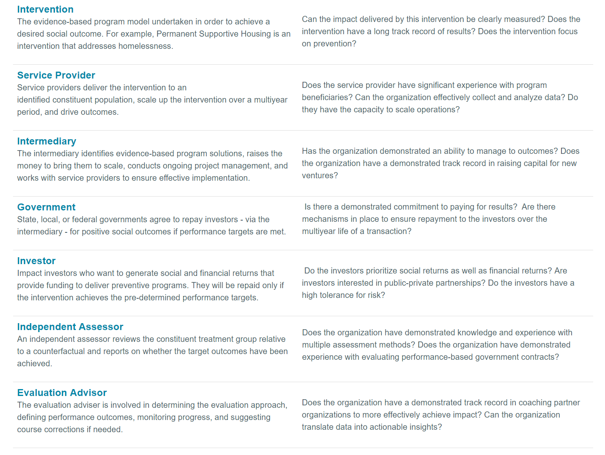

Source: [“[Pay for Success Learning Hub](http://www.payforsuccess.org/learn-out-loud/pfs-101),” Nonprofit Finance Fund, 2016.]

Additional PFS Primers and Toolkits include:

[Urban Institute Pay for Success Project Assessment Tool](http://pfs.urban.org/library/content/pay-success-project-assessment-tool)

[Urban Institute Pay for Success Initiative – Pay for Success 101](http://pfs.urban.org/pfs-101)

[CNCS SIF Pay for Success Resources](https://www.nationalservice.gov/programs/social-innovation-fund/our-programs/pay-success/pay-success-resources) (includes a Pay for Success primer and reports)

[Pay for Success Learning Hub Practitioner Toolkit](http://www.payforsuccess.org/provider-toolkit/rapid-suitability-questionnaires)

[Green and Healthy Homes Pay for Success Resource Page](http://www.greenandhealthyhomes.org/get-help/pay-success)

See also the [Social Finance Pay for Success readiness assessment](http://socialfinance.org/how-to-get-started/). The assessment tool is organized by six of the major components of a strong PFS project:

* **Problem definition:** How clearly defined and understood is the problem?
* **Program strength**: How strong is the proposed solution to address the problem?
* **Provider capacity:** How strong (capacity and effectiveness) is the service provider that could deliver the program?
* **Public system partners and political landscape:** How strong is the political and bureaucratic support from the public partner (i.e. government) for the proposed project and financing structure?
* **Project alignment:** How well do the all the key components of the proposed project fit together in a specific jurisdiction?
* **Project evaluability**: To what extent does the proposed project have a clear, rigorous, and feasible evaluation plan?

#### **PFS - Deliverable 8: Examples of policy that have enabled or encouraged approach**

Legislation:

[The Consolidated Appropriations Act](https://www.gpo.gov/fdsys/pkg/PLAW-112publ74/pdf/PLAW-112publ74.pdf), 2012

This act granted authority to the Department of Labor to run Pay for Success (PFS) Programs.

[The Consolidated Appropriations Act, 2014](https://www.gpo.gov/fdsys/pkg/PLAW-113publ76/pdf/PLAW-113publ76.pdf)

This act granted authority to the Corporation for National and Community Service to run PFS Programs.

[Workforce Innovation and Opportunity Act (WIOA)](https://www.gpo.gov/fdsys/pkg/PLAW-113publ128/pdf/PLAW-113publ128.pdf), 2014

This act granted authority to the Department of Labor to pilot PFS programs.

[Every Student Succeeds Act (ESSA),](https://www.gpo.gov/fdsys/pkg/BILLS-114s1177enr/pdf/BILLS-114s1177enr.pdf) 2015

This act granted authority to the Department of Education to pilot PFS programs.

[Social Impact Partnerships to Pay for Results Act](https://www.gpo.gov/fdsys/search/pagedetails.action?packageId=BILLS-114hr5170ih) ([H.R. 1336/H.R. 5170](https://www.congress.gov/bill/114th-congress/house-bill/5170/all-info?r=1)) passed the House in 2016; the Senate version [(S. 1089)](https://www.congress.gov/bill/114th-congress/senate-bill/1089) failed. There are plans to reintroduce the legislation in 2017.

Relevant summaries of recent legislation and policy guidance:

[America Forward: State of Play on Pay for Success Policy](http://www.payforsuccess.org/resources/america-forward-state-play-pay-success-policy) – an update on Pay for Success legislation and activity

[Authorizing Pay for Success Projects A Legislative Review and Model Pay for Success Legislation](http://www.thirdsectorcap.org/wp-content/uploads/2016/03/Authorizing-Pay-for-Success-Projects-Legislative-Review.pdf)

#### **PFS - Deliverable 9: Future directions**

The Pay for Success field is still relatively young, with only a few structured deals currently in place but a robust pipeline of potential deals in development. The pipeline development work has been funded by Federal programs under the auspices of feasibility studies, technical assistance, deal support, and evaluation. Nonetheless, there has been notable public and private interest in the use of Pay for Success as a means of financing outcomes-based contracts that are rooted in evidence. In November 2015, the White House launched a Pay for Success Interagency Learning Network to deepen and widen knowledge about how PFS can test innovative ideas, scale what’s working, and drive better outcomes. The Network builds on Federal work to date and responds to growing interest among states and communities. The FY2016 and FY2017 budget both called for increased spending for Pay for Success initiatives. Pay for Success has wide-ranging, bipartisan support as well as private supporters, raning from the American Enterprise Institute to large foundations like the Kresge Foundation to large investors like Goldman Sachs and Bank of America.

#### **PFS -Deliverable 7: Online inventory of resources**

#### For more information on the Pay for Success Interagency Learning Network, contact:

John Tambornino, Senior Advisor, Evidence Team – OMB, [jtambornino@omb.eop.gov](mailto:jtambornino@omb.eop.gov)

**Further Reading**

[Pay for Success Learning Hub](http://www.payforsuccess.org/) is a comprehensive source of information on Pay for Success. It’s run by the Nonprofit Finance Fund, which is supported with some Federal funding through CNCS’s SIF grants.

* [PFS White Paper](http://www.payforsuccess.org/sites/default/files/social_finance_white_paper_2014.pdf)

Federal resources:

“[Improving Outcomes through Pay for Success – FY 2016 Fact Sheet](https://www.whitehouse.gov/sites/default/files/omb/budget/fy2016/assets/fact_sheets/improving-outcomes-through-pay-for-success.pdf),” Office of Management and Budget, 2015. A summary of Pay for Success initiatives included in the 2016 Budget

“[Improving Outcomes Through Pay for Success – FY 2017 Fact Sheet](https://www.whitehouse.gov/sites/default/files/omb/budget/fy2017/assets/fact_sheets/improving-outcomes-through-pay-for-success_0.pdf),” Office of Management and Budget, February 2016. A summary of Pay for Success initiatives included in the 2017 Budget

“[Paying for Success: Federal Budget Fiscal Year 2012](https://www.whitehouse.gov/omb/factsheet/paying-for-success),” Office of Management and Budget, 2012.

“[Invest in What Works - Pay for Success Fact Sheet](http://results4america.org/tools/invest-works-pay-success/),” Results for America, August 18th, 2015. A summary of Federal investments and budget requests for PFS programs.

Additional Pay for Success Resources:

[Rockefeller Foundation’s Social Impact Bond website](https://www.rockefellerfoundation.org/our-work/initiatives/social-impact-bonds/)

[CNCS SIF Pay for Success Program Resources](https://www.nationalservice.gov/programs/social-innovation-fund/our-programs/pay-success/pay-success-resources)

[CNCS SIF Pay for Success Briefs](https://www.nationalservice.gov/programs/social-innovation-fund/our-programs/sif-pay-success/pay-success-national-evaluation)

[CNCS SIF Pay for Success Primer](https://www.nationalservice.gov/sites/default/files/documents/SIF%20-%20A%20Primer%20on%20Pay%20for%20Success.pdf)

[1st Generation Pay for Success Report](http://www.payforsuccess.org/sites/default/files/Pay%20for%20Success_The%20First%20Generation.pdf)

Articles:

Rangan, V.K. and Chase, L., “[The Payoff of Pay-for-Success](https://ssir.org/up_for_debate/article/the_payoff_of_pay_for_success),” Stanford Social Innovation Review, Fall 2015.

# “[Pay for Success: Collaboration among Federal Agencies Would be Helpful as Governments Explore New Financing Mechanisms](http://www.gao.gov/products/GAO-15-646),” US Government Accountability Office, September 9th, 2015.

**Annex of interviews**

Anna Fogel, Director, Social Finance, Inc.

Anne Healy, Chief, Development Innovation Ventures (DIV) and Discover & Test Division at USAID

Parita Patel, Sr. Strategy and Innovation Officer, SIF, CNCS

Neil Seftor, Senior Economist, Mathematica Policy Research

Chris Spera, Division VP, Abt Associates

1. Validity generally refers to how accurately a conclusion, measurement, or concept corresponds to what is being tested. [↑](#footnote-ref-1)